Callsheet User Manual

Film Festival Management Platform

Version 1.0 | July 2026

Table of Contents
- Getting Started
  - Logging In
  - Setting Your Password
  - The Dashboard
- Navigating the Platform
  - The Sidebar
  - Selecting a Festival Year
- Modules
  - Festival at a Glance
  - Titles & Programs
  - Ticketing Grid
  - In Attendance
  - Press Management
  - Press Screenings
  - Screener Access
  - Screener Requests
  - Photo Shoots
  - Red Carpets
  - Interview Management
  - Special Events
  - Contacts Management
  - Venue Management
- Common Features
  - Searching & Filtering
  - Sorting
  - Card Popups
  - Importing Data
  - Exporting Data
- Account Settings
- Administration
  - Managing Users
  - Setting Permissions
  - Reports & Archives

1. Getting Started

Logging In
Navigate to the Callsheet login page in your browser. Enter the email address and password provided to you by your administrator.
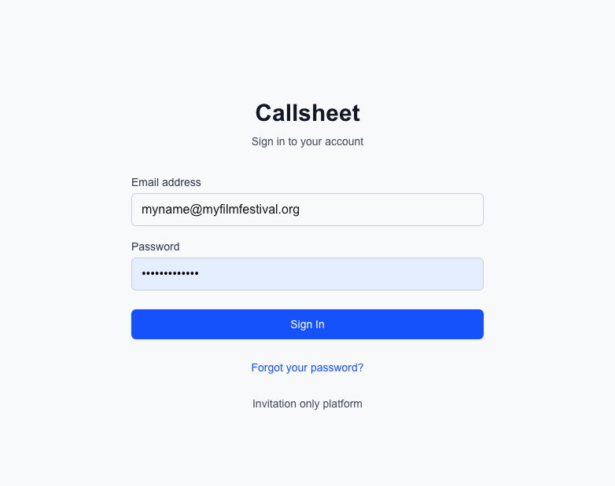

If you’ve forgotten your password, click Forgot Password to receive a reset link via email.

Setting Your Password
On your first login, you will be prompted to set a new password. Choose a strong password — the strength indicator will guide you.

The Dashboard
After logging in, you’ll land on the Titles & Programs module by default. The platform is organized into modules, each handling a different aspect of festival operations. You’ll only see modules you have permission to access.

2. Navigating the Platform

The Sidebar
The sidebar on the left is your main navigation. It displays:
- Callsheet logo at the top
- Festival year selector — choose which festival edition to work with
- Module list — click any module name to navigate to it
- Admin section — visible only to administrators
- Logout button at the bottom
Each module has an icon for quick visual identification.

Selecting a Festival Year
Use the dropdown at the top of the sidebar to switch between festival years. All data throughout the platform is filtered by the selected year. Archived years appear in the dropdown but are read-only.
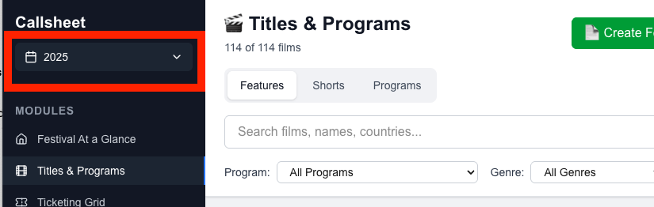

3. Modules

Festival at a Glance
Your festival’s home base. This module shows key information at a glance:
- Edition number and festival name (e.g., “62nd Chicago International Film Festival”)
- Festival dates
- Important links — quick access to external resources (festival website, ticketing platform, etc.)
- Statistics — total films, shorts programs, public screenings, and venues

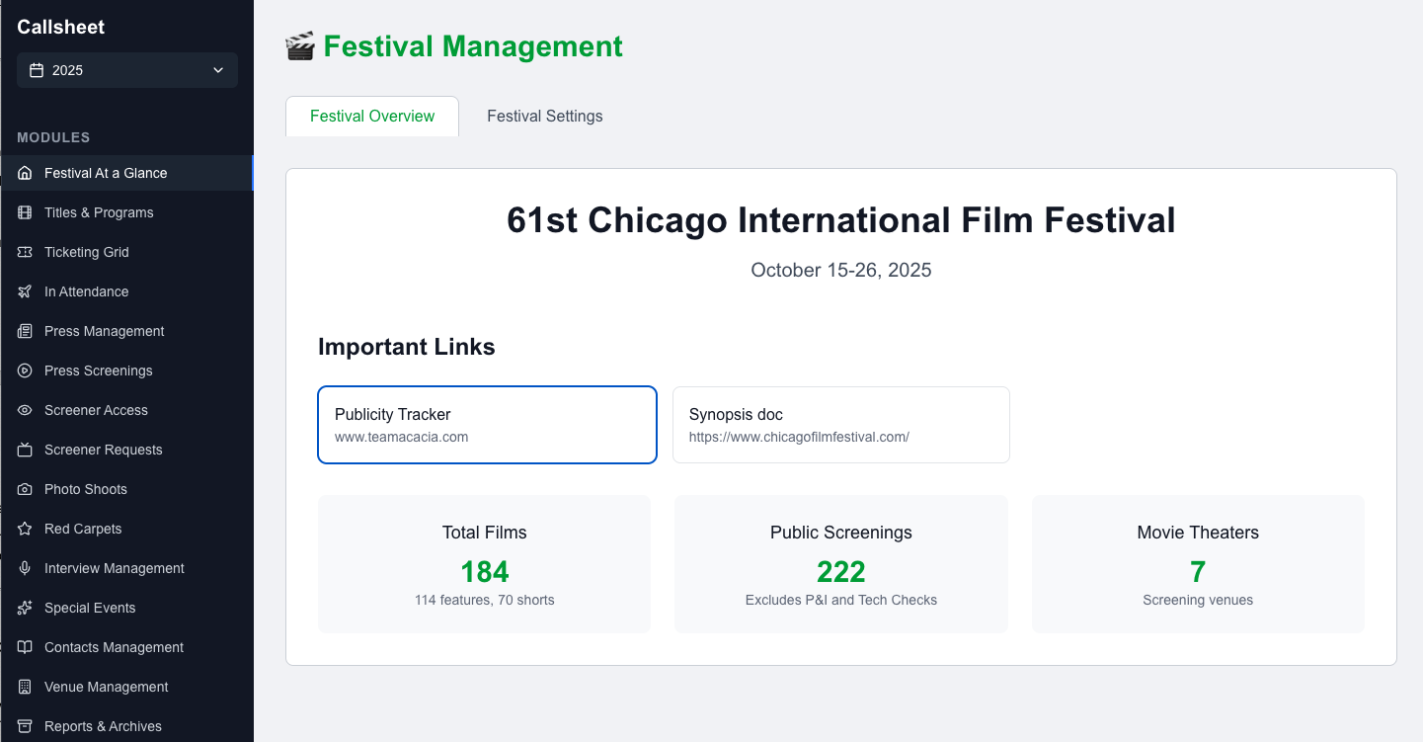
The Festival Settings tab (admin only) allows editing the festival name, dates, edition number, and managing important links with drag-and-drop reordering.

Titles & Programs
The central hub for managing your festival’s film lineup. Organized into three tabs:
Features Tab
A searchable, sortable table of all feature films. Each row displays the film’s title, director, countries, programs, genres, runtime, language, and more.
- Click a film title to open its detailed card popup
- Use the search bar to find films by title or director
- Use filters to narrow by program, genre, or premiere status
- Click Add Film to create a new entry (Admin only)
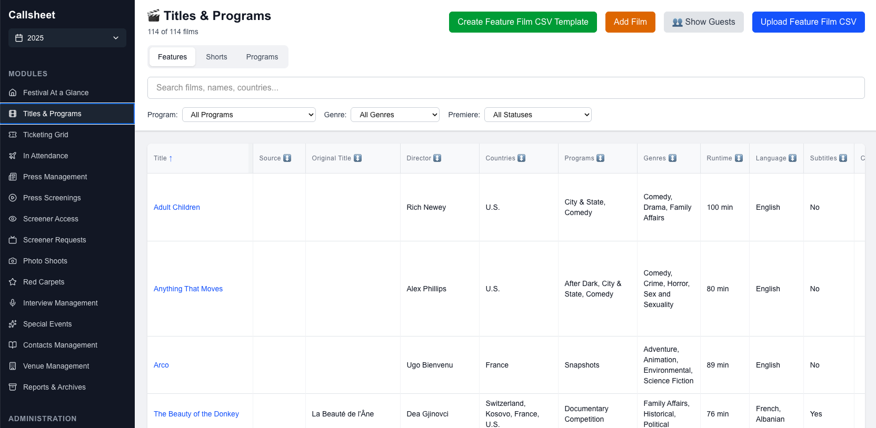

Shorts Tab
Displays short films grouped by shorts program. Works similarly to the Features tab — search, filter, sort, and click titles to view details.
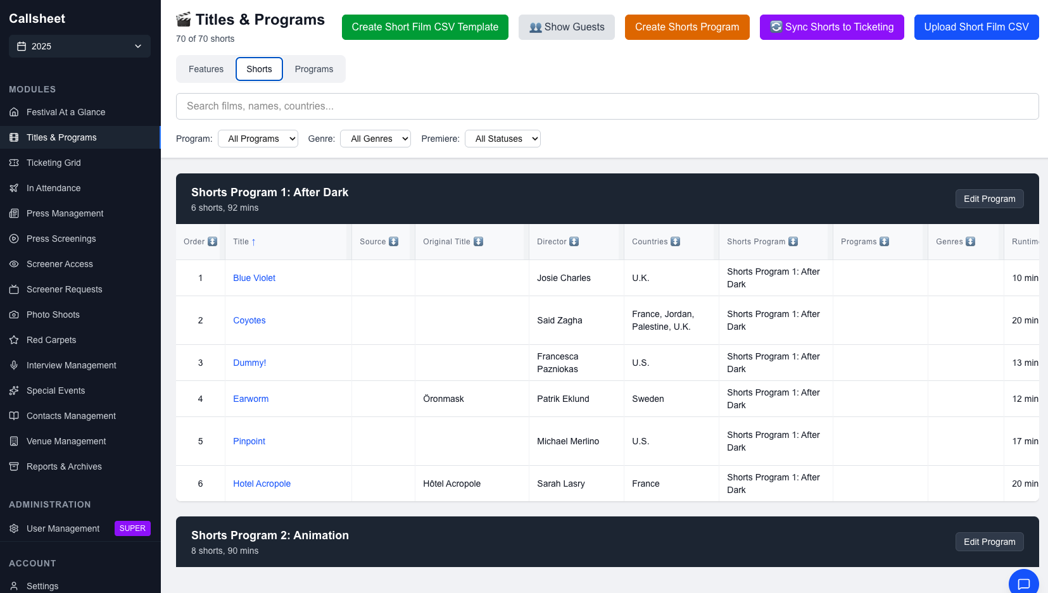

TIP: After you’re done uploading shorts or editing a Shorts Program, click “Sync to Ticketing” to ensure that the run time is correct in the Ticketing Grid module.

Programs Tab
Manage non-screening festival programs like masterclasses, panel discussions, and special presentations. Add, edit, or export program information.

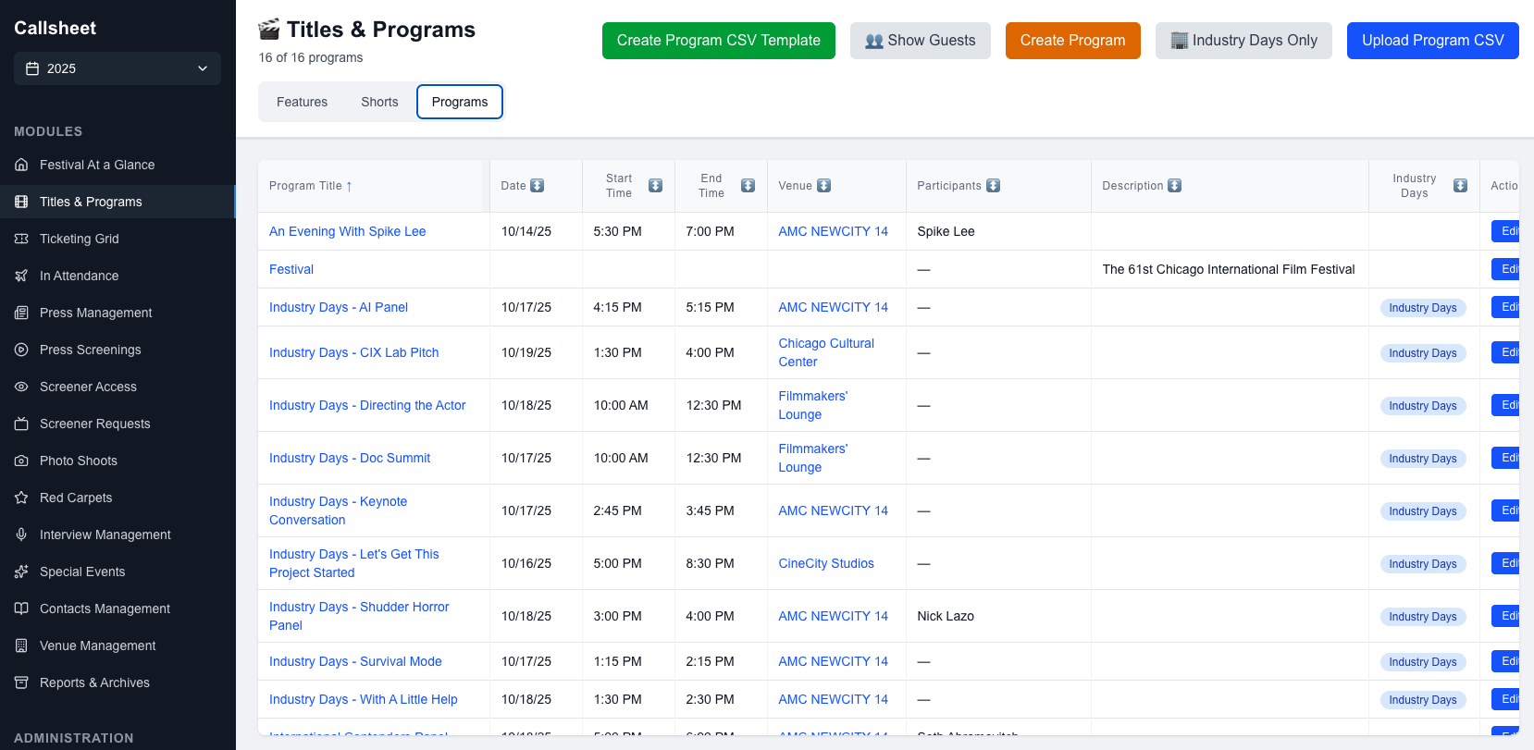
Adding or Editing a Film – Admin Only
Users with edit access to this module can add and edit films. Click Add Film or click the edit icon on an existing film to open the film form. Fill in the relevant fields — title, director, runtime, language, genre, and technical details — then save.

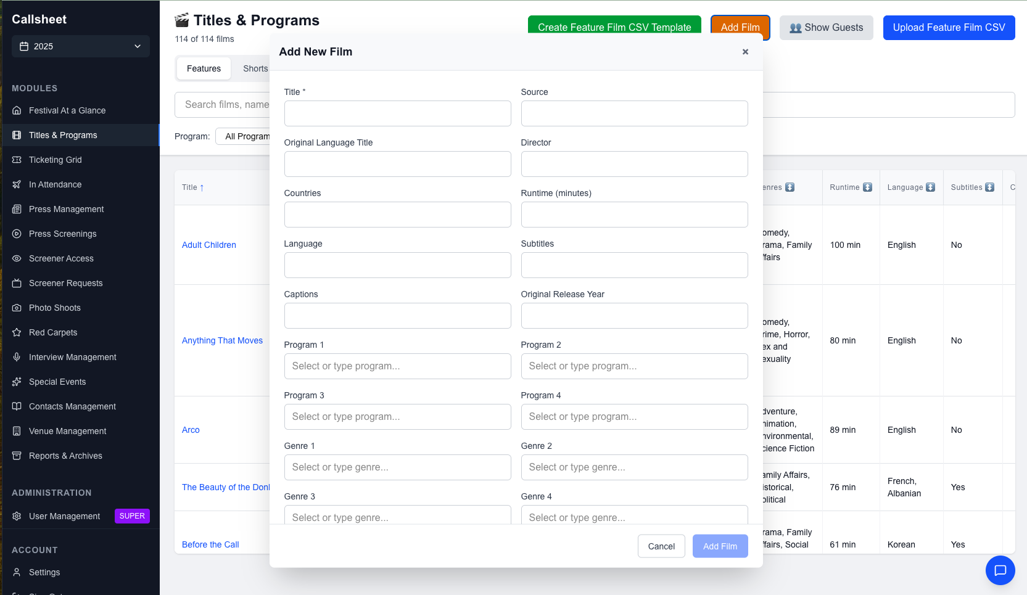

To bulk add films and programs, click “Create Features Template” – this will download a CSV template to your computer. Once this is updated, click “Upload CSV” to import all of the data at once.
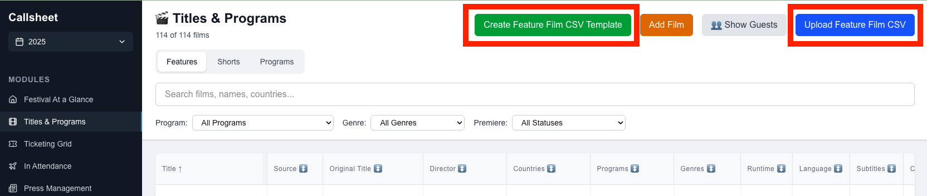

NOTE: Do not change any of the column headers on the CSV – they are needed to match with the system’s column headers in order to display your data correctly.

Ticketing Grid
A calendar-style board view for managing public screenings. Screenings are organized by date with columns for each venue/theater.
- Navigate dates using the date picker or arrow buttons
- Search by film title, venue, or notes
- Configure the view — choose which venues to display, reorder columns, and set color coding by program
- Click a film title to view its card popup
- Click Add Screening to schedule a new public screening
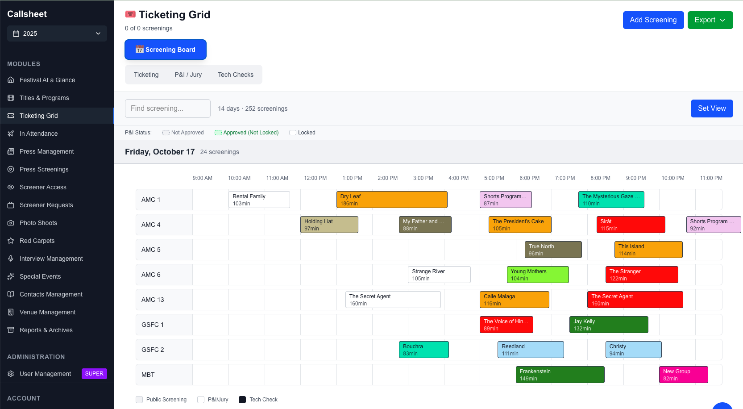

Each screening card shows the film title, time, runtime, and venue/house. Color coding helps distinguish different program categories.
Clicking a title summons the Film Card pop-up, which displays more information about the film, associated filmmaker guests, press opportunities, and more.
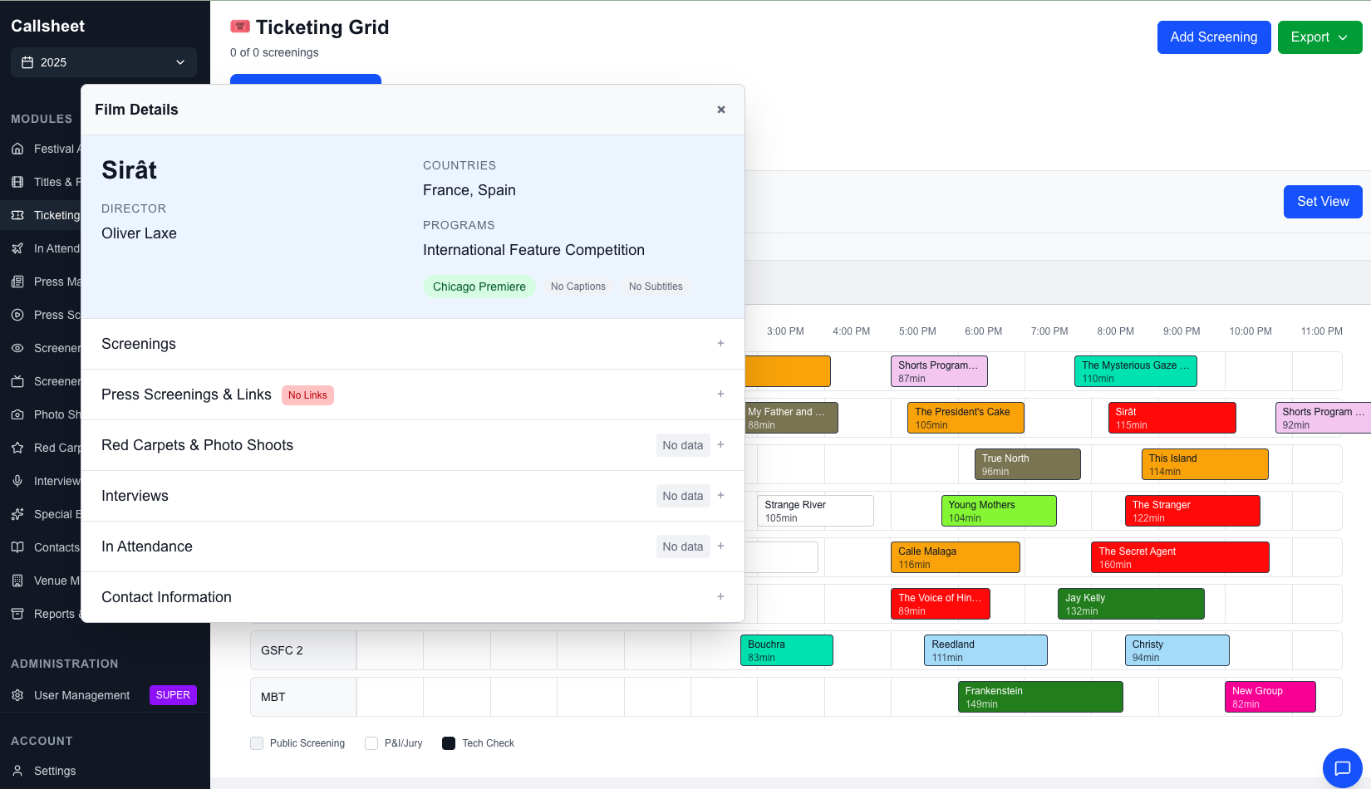

Setting Up the View (Admin only)
Module Admins can click the Set View button to open the configuration panel. Select which venues to include, drag to reorder them, and assign colors to different programs for easy visual identification.
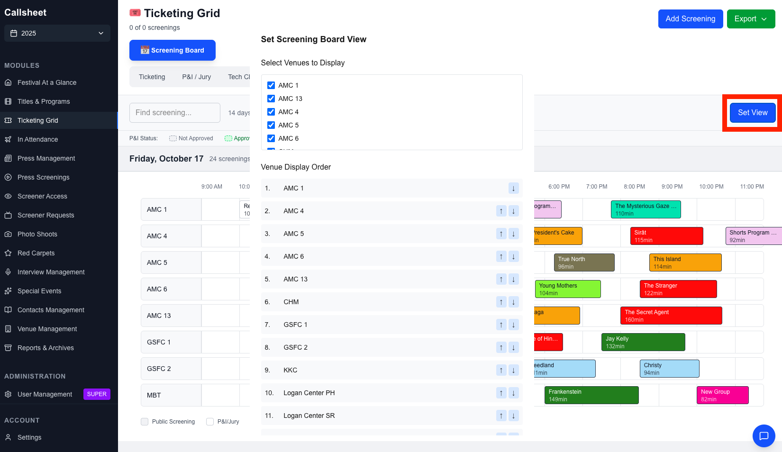

In Attendance
Track festival guests from arrival through departure. The main table shows each guest’s name, country, guest type, confirmation status, travel arrangements, and check-in status.
- Search by name, email, or phone
- Filter by guest type (Features, Shorts, Industry, Jury, etc.), confirmation status, or check-in status
- Click Check In or Check Out to toggle a guest’s status
- Click a guest name to view their full details
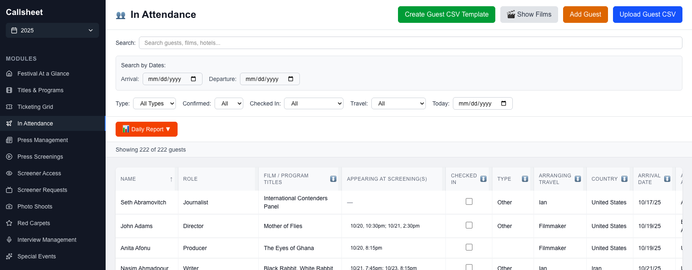

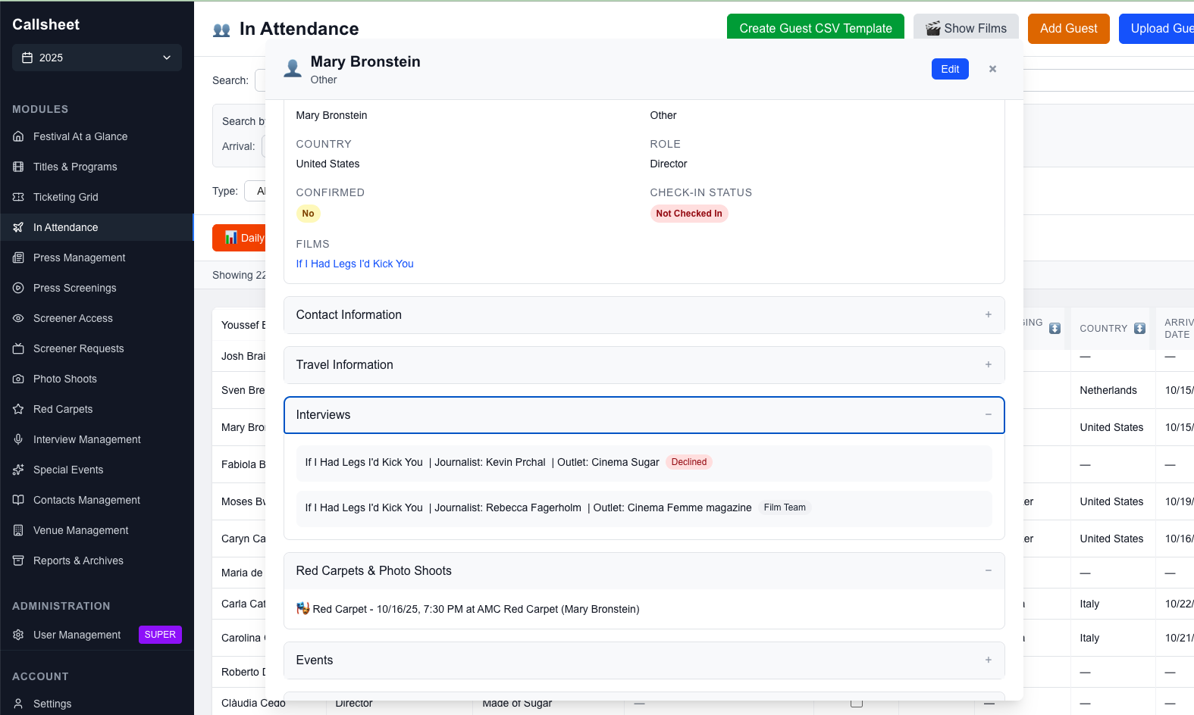

Adding a Guest (Admin only)
Admins can add guests and edit their details. Click Add Guest and fill in their details — name, contact information, guest type, travel dates, flight info, hotel, dietary restrictions, and any special requirements.
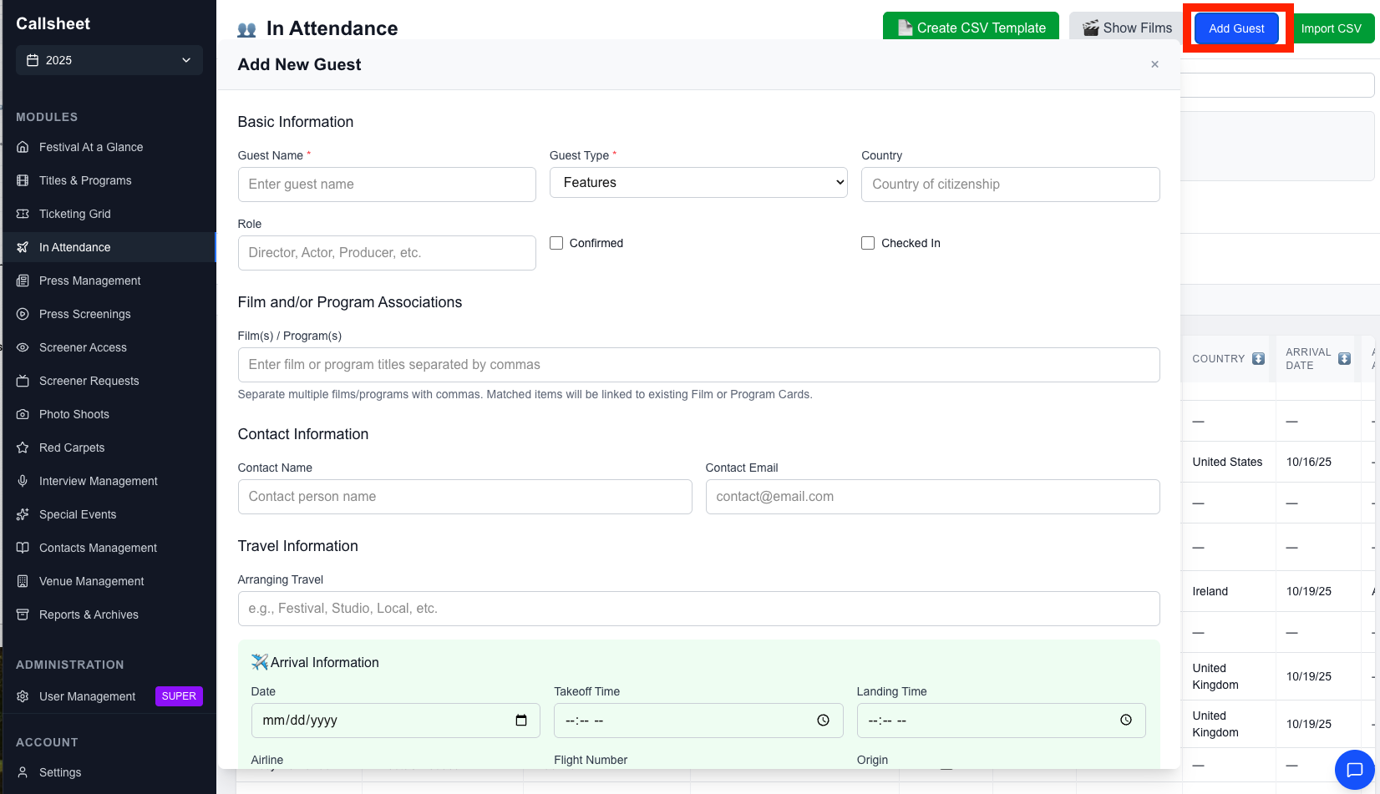

Admins can also bulk import multiple guests at once. click “Create CSV Template” – this will download a CSV template to your computer. Once this is updated, click “Upload CSV” to import all of the data at once.

Linking Guests to Films
Open a guest’s details and use the Films section to associate them with one or more festival films.
Daily Reports
Click Daily Report to generate a Word document (.docx) for a specific date, including:
- Guest arrivals with flight details
- Guest departures
- All guests currently in attendance
- Hotel information
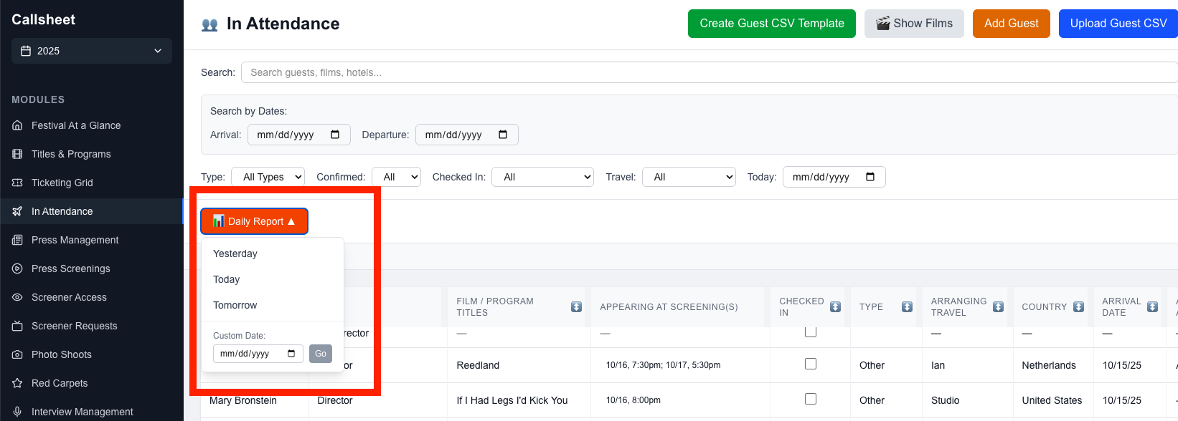

Press Management
A database of journalists and media contacts covering the festival.
Each entry tracks:
- Name, email, phone, and preferred contact method
- Media outlet(s) and outlet type (Print/Online, TV, Radio, Podcast, etc.)
- Social media handles and website
- Rotten Tomatoes accreditation status
- Accreditation level - P (Priority), G (General), S (Social Media), or Unassigned
- Credential pickup status

- Search by name, outlet, or email (accent-insensitive)
- Filter by accreditation level, outlet type, or credential pickup status
- Click a journalist’s name to view their full press card popup

Press Screenings
Schedule and manage press-only screenings, separate from public ticketed screenings.
Each screening includes the date, time, film, venue/house, assigned staff member, and optional notes.
- Search by film title, venue, or staffer
- Sort by date, film, venue, or staffer
- Click the film title to view its card popup

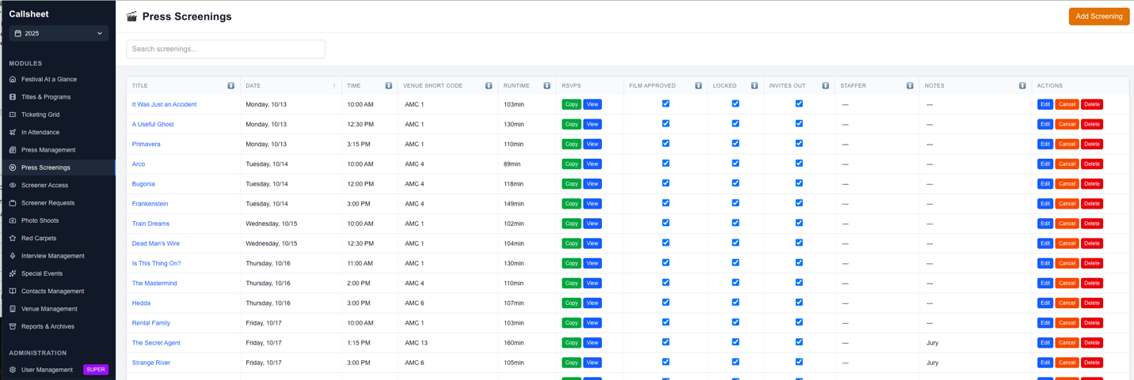

Screener Access
Track which films have digital screener links available for press review.
Each film displays its current access status:
Status | Meaning
TBD | Not yet determined
Cinesend | Uploaded to the Cinesend platform
Link Available | Has a direct streaming link (URL and password shown)
Request Link | Link must be requested from the distributor
No Links | No digital access available
- Search by film title
- Filter by access type
- Update access status and enter streaming URLs/passwords as they become available

Screener Requests
Track press requests for screener links or screening tickets.
Each request captures the requester’s name, outlet, email, the film requested, and the request type (screener link or screening ticket). Requests move through three statuses:
New → Requested → Fulfilled
- Search by requester, outlet, or film
- Filter by status or request type
- Update status as requests are processed

Photo Shoots
Coordinate photo shoots with festival guests and filmmakers.
Each shoot tracks:
- Date, call time, and shoot time
- Associated film(s) and guest subject(s)
- Venue/house and photographer/videographer
- Whether an intro Q&A is included
- Selects received status (Pending / Received)
- Sent to PR status (Pending / Sent)
Click film titles or subject names to view their respective card popups. Mark selects as received and track PR delivery.

Red Carpets
Manage red carpet events, linking them to films and guest attendees.
Each event includes:
- Date, start time, and guest call time
- Venue/house
- Associated films/programs and guest subjects
- Screening start time
- Links to RSVP form, RSVP responses, and run of show
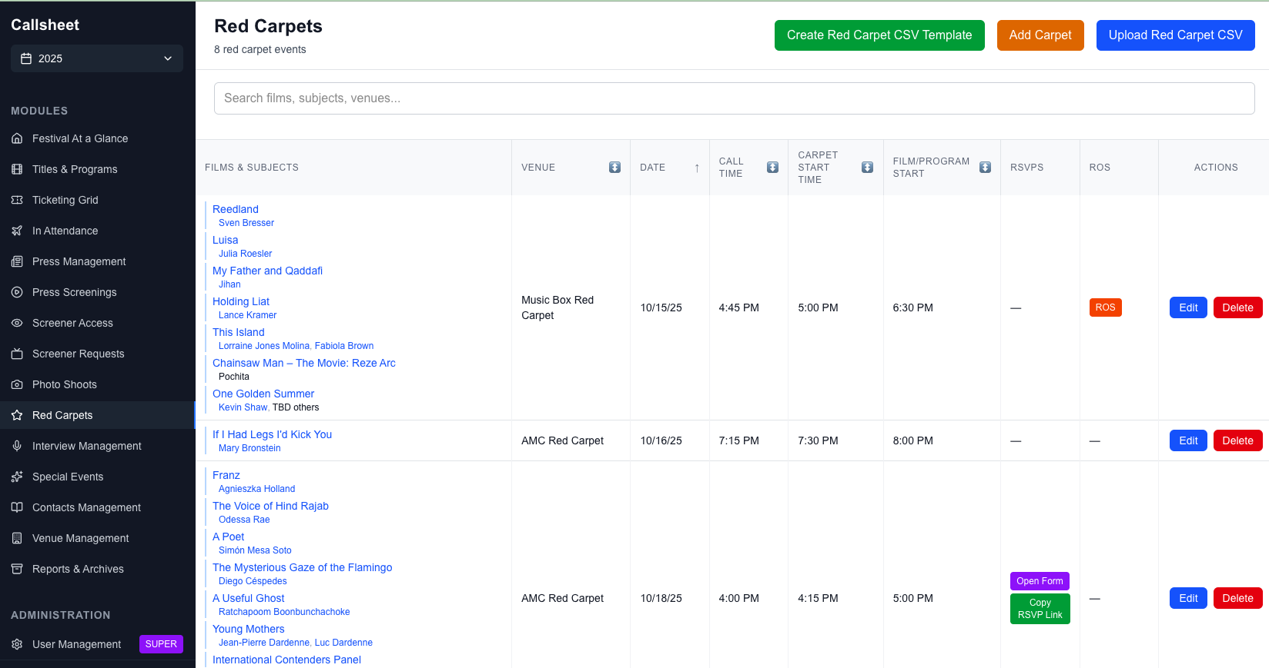

Click film titles or subject names to view details. Add RSVP and run-of-show URLs for quick team access.

Interview Management
Track and manage press interviews with filmmakers and talent.
The table displays each interview’s film, journalist, outlet, subject(s), status, date, time, and location. Interviews move through these statuses:
Status | Meaning
TBD | Not yet assigned
Pitching | Being pitched to press
Subject Pending | Awaiting subject confirmation
Scheduled | Confirmed and scheduled
Film Team | Handled by the film’s team
Complete | Interview completed
Declined | Interview declined
Key features:
- Inline editing — click most cells to edit them directly, then press Enter to save
- Status dropdown — quickly change status from the table
- Complete checkbox — one-click toggle from Scheduled to Complete
- Linked cards — toggle “Show Films,” “Show Guests,” or “Show Journalists” to make names clickable, opening their card popups

Special Events
Manage galas, dinners, panels, receptions, and other special festival events.
Each event captures extensive details including date/time, event type, venue, associated films and guests, catering and beverage information, photography coverage, press access, RSVP tracking, and expected/actual attendance.
Three view modes:
- Grid — sortable table view
- Calendar — visual calendar layout
- Timeline — chronological list
Switch between views using the toggle buttons. Filter by event type, venue, press access, or photography coverage.

Contacts Management
Maintain a directory of film representatives, distributors, sales agents, and production companies.
Two views:
- By Contact — browse all contacts and see their associated films
- By Film — browse all films and see their associated contacts
Each contact entry includes name, company, email, phone, contact type, and notes. Link contacts to one or more films to keep track of who represents what.

Venue Management
Manage festival venues and their theater houses/screens.
Each venue entry includes:
- Venue name, address, and type (Movie Theater, Event Space, etc.)
- Contact information
- Theater houses — individual screens or rooms within the venue, each with a name, short code (used in the Ticketing Grid), and seat count
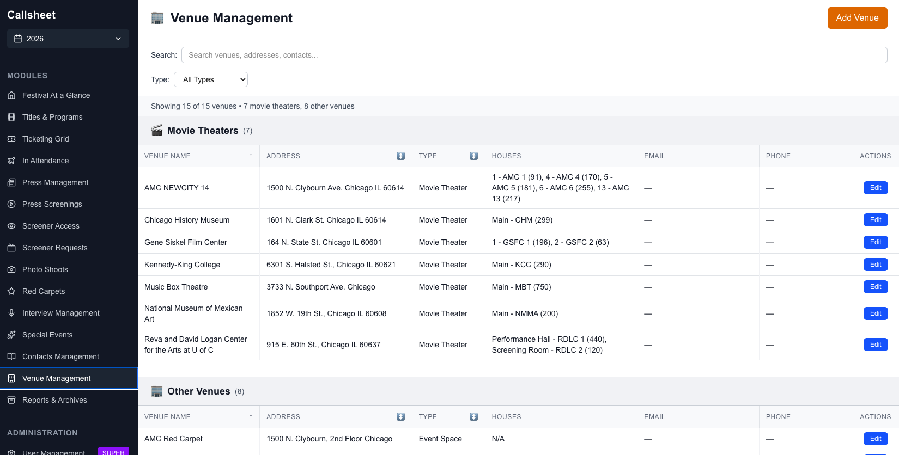

Click Add Venue and fill in the venue details. For movie theaters, add individual theater houses with their names, short codes, and capacities.
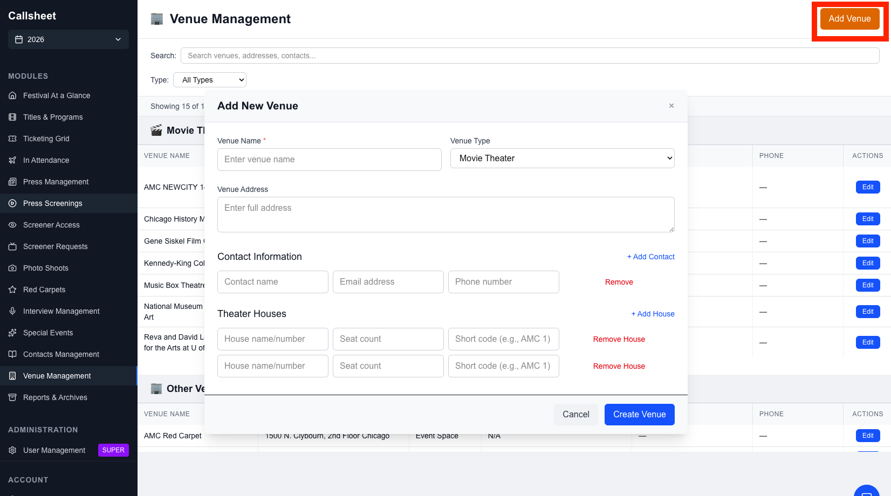

4. Common Features
These features work consistently across all modules.

Searching & Filtering
Every module has a search bar at the top. Type to search across multiple fields — results filter in real time. Search is accent-insensitive, so searching “Gonzalez” will match “González.”
Filter buttons appear next to the search bar when a module supports filtering. Click a filter to narrow results by category (e.g., guest type, accreditation level, status). Active filters are visually highlighted.
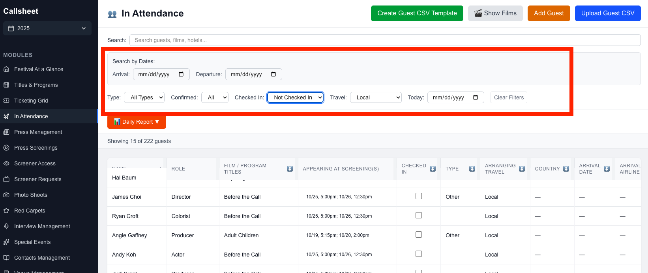

Sorting
Click any column header to sort by that column. Click again to toggle between ascending and descending order. An arrow indicator (up/down) shows the current sort direction.

Card Popups
Click on a film title, guest name, journalist name, or venue name (when clickable) to open a read-only card popup with full details. Card popups are a quick way to view information without leaving your current module.

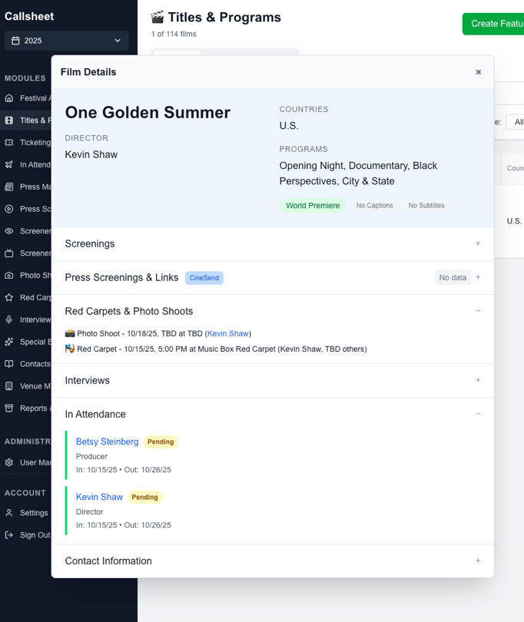

Importing Data
Most modules support bulk import from Excel or CSV files.
- Click the Import button (or download the import template first)
- Select your file
- A field mapping dialog lets you match your spreadsheet columns to Callsheet fields
- Review the preview and confirm
- Records are created in bulk
Tip: Download the import template first to see the expected format and column names.

Exporting Data
Click the Export button in any module to download the current view as an Excel file. Exports respect your active search and filter settings — what you see is what you get.

5. Account Settings
Access your account settings by clicking Settings in the sidebar.
From here you can:
- View your account information (email, name, role)
- Change your password — enter your current password, then your new password with confirmation. The strength indicator helps you choose a secure password.

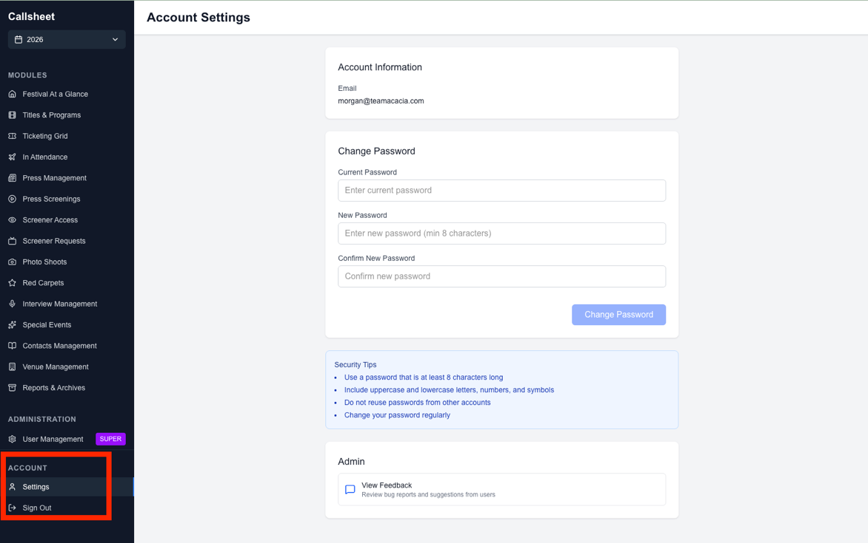

6. Administration (Admin Only)
The following sections are only available to users with Admin or Super Admin access.

Managing Users
Navigate to the Administration section in the sidebar to manage user accounts.
The users table shows all accounts with their email, name, role, and access level.
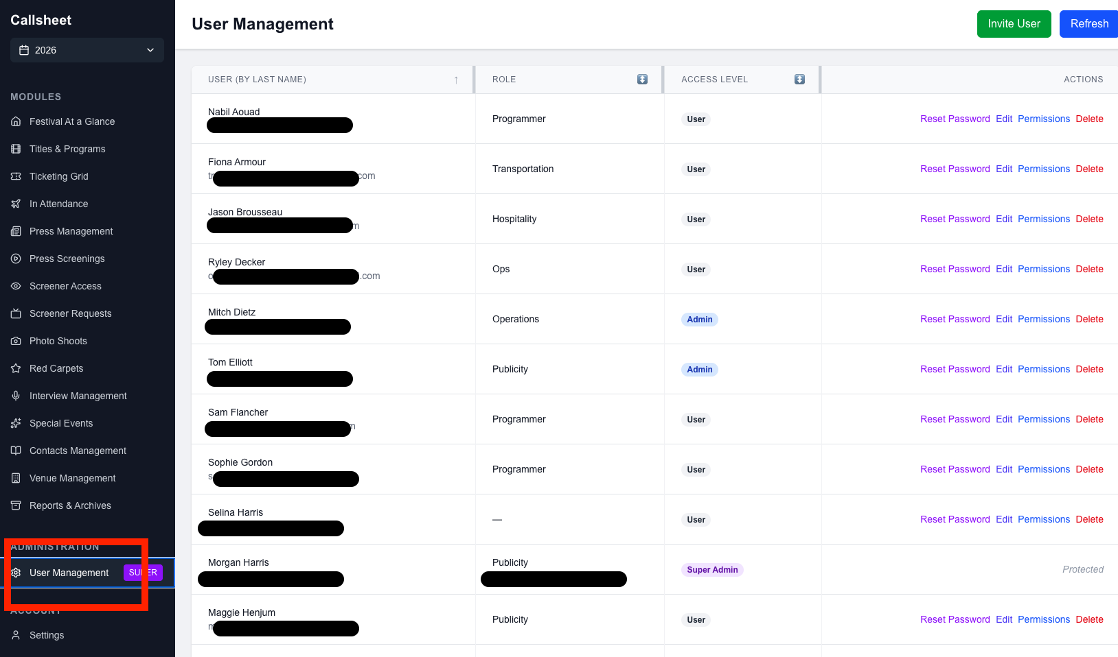

Adding a User
- Click Invite User
- Enter their email address (required), name, role, and phone number
- Click Save
- The new user will receive an email to set their initial password

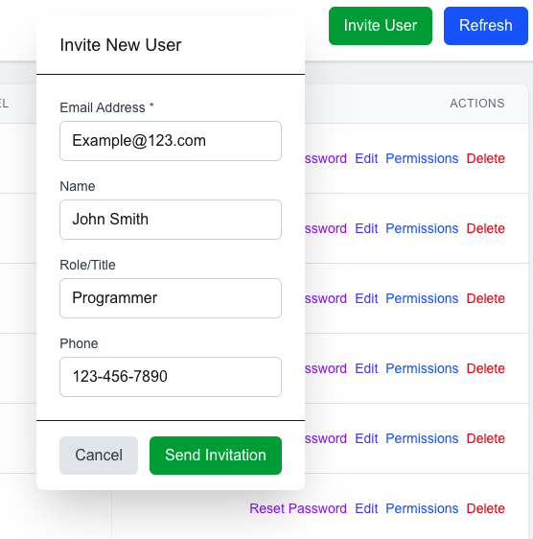
Editing a User
Click on a user to update their name, role, phone number, or admin status.
Deleting a User
Click the delete button next to a user to remove their account. This action cannot be undone.

Setting Permissions
Callsheet uses a role-based permission system with three access levels:
Level | Description
User | Can only access modules they’ve been granted permission to
Admin | Can access all modules and the admin panel
Super Admin | Full access including user management and festival settings
Configuring Module Permissions
- In the Administration panel, click on a user
- Click Manage Permissions
- For each module, toggle:
  - Read — the user can view the module
  - Edit — the user can add, edit, and delete data in the module
- Click Save Permissions
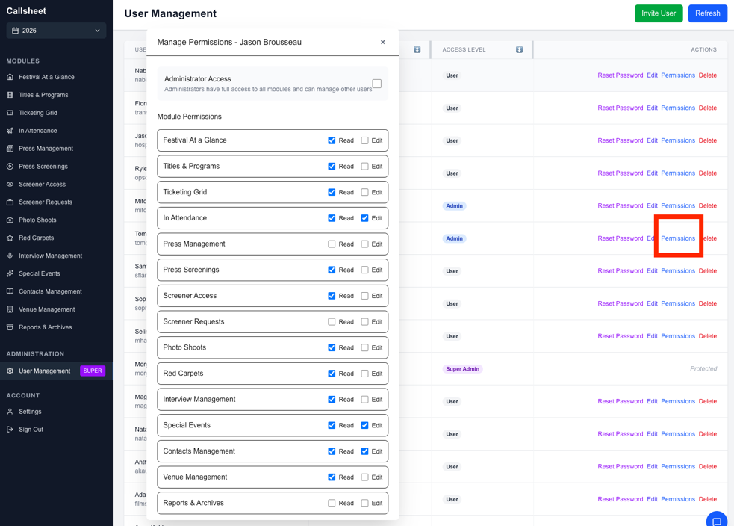

Modules available for permission assignment:
- Festival Overview
- Titles & Programs
- Ticketing Grid
- In Attendance
- Press Management
- Press Screenings
- Screener Access
- Screener Requests
- Photo Shoots
- Red Carpets
- Interview Management
- Special Events
- Contacts Management
- Venue Management
- Reports & Archives

Reports & Archives
Navigate to Reports & Archives to manage festival years.
Creating a New Festival Year
- Click Create New Festival Year
- Enter the year, edition number, festival name, and date range
- Choose what to copy from the previous year:
  - Venues
  - Contacts
  - Press database
  - Template programs
- Click Create
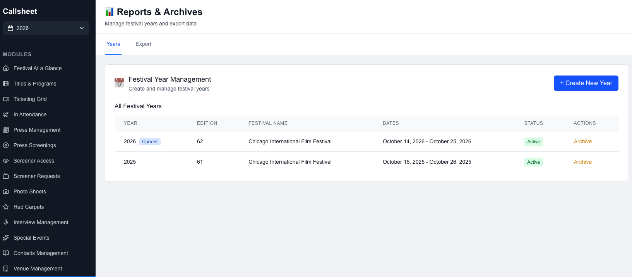

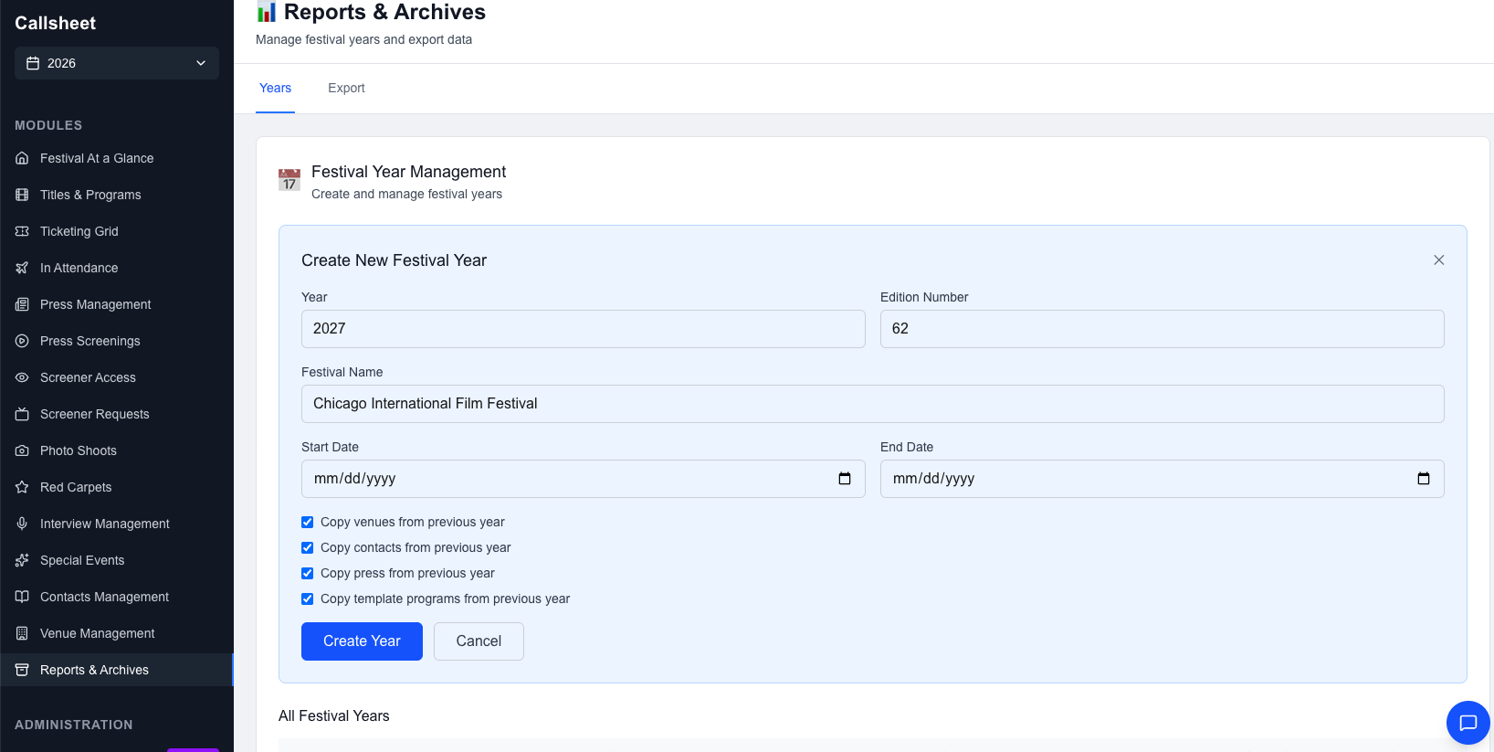

The system will set up the new year with the selected data, giving you a head start.
Archiving a Festival Year
Once a festival is complete, click Archive next to that year. Archived years remain accessible via the year selector in the sidebar but are read-only.
To restore an archived year, click Unarchive.
Exporting Festival Data
Click Export next to any festival year to download a complete Excel workbook containing all data — films, guests, press, venues, screenings, events, interviews, and more.
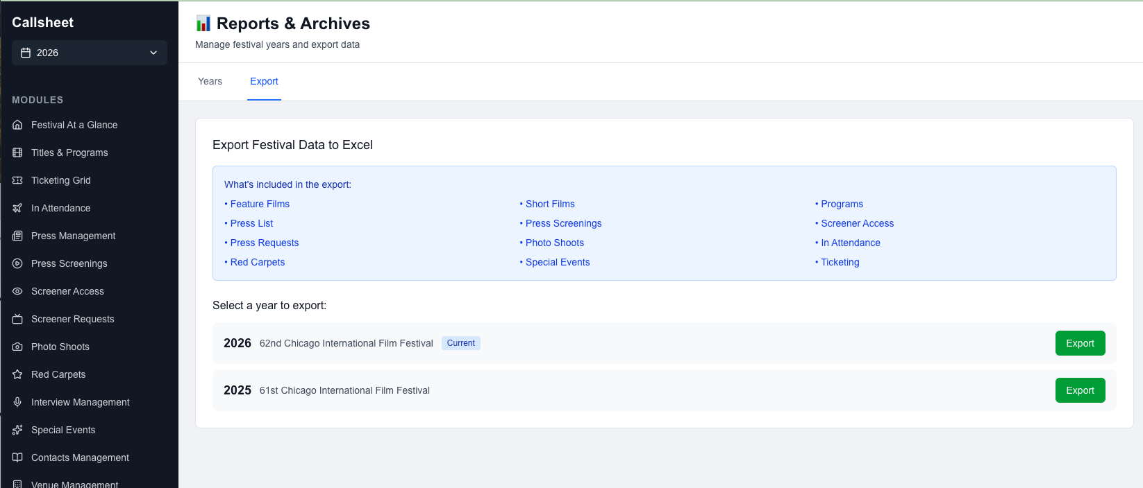

Quick Reference
Task | Where to Go
Add a film | Titles & Programs → Add Film
Schedule a public screening | Ticketing Grid → Add Screening
Schedule a press screening | Press Screenings → Add Screening
Check in a guest | In Attendance → Click Check In
Generate a daily guest report | In Attendance → Daily Report
Track a screener link | Screener Access → Update access type
Log a press request | Screener Requests → Add Request
Schedule an interview | Interview Management → Add Interview
Create a special event | Special Events → Add Event
Add a venue | Venue Management → Add Venue
Add a press contact | Press Management → Add Press
Add a film contact | Contacts Management → Add Contact
Change your password | Settings → Change Password
Add a new user | Administration → Add User
Set user permissions | Administration → User → Manage Permissions
Start a new festival year | Reports & Archives → Create New Festival Year
Export all festival data | Reports & Archives → Export

Callsheet is developed and maintained by Acacia Consulting Group.
For technical support, contact your system administrator.

